D8.2 – Communication, dissemination and replication strategy v1

Legal disclaimer
This document is issued within the frame and for the purpose of the UNCHAIN project. This project has received funding from the European Union’s Horizon Europe research and innovation programme under Grant Agreement No. 101103812. The UK participant in Horizon Europe Project UNCHAIN, is supported by UKRI grant number 10078841 Lancaster University.
Funded by the European Union. Views and opinions expressed are however those of the author(s) only and do not necessarily reflect those of the European Union or CINEA. Neither the European Union nor the granting authority can be held responsible for them.

Copyright statement
The work described in this document has been conducted within the UNCHAIN project. This document reflects only the UNCHAIN Consortium view and the European Union is not responsible for any use that may be made of the information it contains.
This document and its content are the property of the UNCHAIN Consortium. All rights relevant to this document are determined by the applicable laws. Access to this document does not grant any right or license on the document or its contents. This document or its contents are not to be used or treated in any manner inconsistent with the rights or interests of the UNCHAIN Consortium or the Partners detriment and are not to be disclosed externally without prior written consent from the UNCHAIN Partners.
Each UNCHAIN Partner may use this document in conformity with the UNCHAIN Consortium Grant Agreement provisions.

Deliverable details
Deliverable No. | 8.2
Deliverable Type | R – Document, report
Dissemination Level | PU - Public
Work Package No. | 8
Work Package Title | Communication, replication, and upscaling
Task No. | 8.2
Task Title | Communication and dissemination activities
Author(s) | Melina Zarouka, Zsofia Jakoi
Status (F:final; D:draft; RD:revised draft) | F
File name | D8.2 – Communication, dissemination and replication strategy v1
Version | 0.3
Task start date and duration | 01/05/2023 – 31/10/2026
Due Date | M6 (October 2023)
Delivery Date | 31/10/2023

Review History of Deliverable
Version No. | Date | Revision Details
0.1 | 09/10/2023 | 1st Draft Version
0.2 | 24/10/2023 | 2nd Draft Version
0.3 | 30/10/2023 | 3rd Draft Version

Reviewers of Deliverable
Reviewers name | Organisation | Date | Version Reviewed
Mónica Castañeda | EITUM | 17/10/2023 | V0.1
Juan Fernando Gimenez Pla | IBV | 17/10/2023 | V0.1
Julia Hümpfner | MAD | 17/10/2023 | V0.1
Elena García Jiménez | ETRA | 19/10/2023 | V0.1
Konstantinos Zografos | ULANC | 19/10/2023 | V0.1
Konstantinos Zografos | ULANC | 27/10/2023 | V0.2
Elena García Jiménez | ETRA | 30/10/2023 | v.03

Table of Contents
1. Executive Summary 9
2. Introduction 9
3. Ethics 9
3.1. Data Management 9
4. Consideration of Gender Issues 9
5. Establishing a united identity 10
5.1. EU funding disclaimer 10
5.2. Cooperation with similar projects and initiatives 12
6. Communication Objectives 17
6.1. Target Groups of UNCHAIN 19
6.2. Project motto 21
6.3. Key messages of the UNCHAIN project 21
6.3.1. Target Groups 23
6.4. Online Presence 24
6.4.1. Accessibility 24
6.4.2. Website 25
6.4.3. Social Media Channels 27
6.4.4. Newsletter 30
6.5. Local communication strategy 31
6.5.1. Establishing the Local Strategies 32
7. Dissemination Objectives 34
7.1. Multistakeholder Approach 34
7.2. Strategic Dissemination 35
7.3. Event Attendance 36
8. Replication Objectives 37
8.1. Scalability and Replication 37
8.1.1. Stakeholder Engagement Group 38
8.2. Contribution to Standardisation 39
9. Key Performance Indicators to achieve 40
10. Conclusion 41
Annex I. 43
1. POLIS Network Privacy Policy 43
2. POLIS Network Cookie Policy 43

Acronyms
Acronym | Meaning
CEN | European Committee for Standardization
CENELEC | European Committee for Electrotechnical Standardization
CTA | Call-to-Action
Dx.x | Deliverable x.x
EC | European Commission
ETSI | European Telecommunication Standards Institute
EU | European Union
GA | Grant Agreement
GDPR | General Data Protection Regulation
IEC | International Electrotechnical Commission
ITU | International Telecommunication Union
ISO | International Organization for Standardization
KPI | Key Performance Indicator
Mx | Month x
PGP | Preferred Gender Pronoun
SEG | Stakeholder Engagement Group
Tx.x | Task x.x
UCC | Urban Consolidation Centre
UDC | Urban Distribution Centre
UNSDGS | United Nations Sustainable Development Group

Table of Figures
Figure 1 - EU Funding Disclaimer 13
Figure 2 - CIVITAS Funding Disclaimer 13
Figure 3 - UKRI Grant Logo 13
Figure 4 - UNCHAIN Communication and Dissemination Partner Types 21
Figure 5 - UNCHAIN Website Landing Page 26
Figure 6 - Service page for SUMPs and SULPs guidance tool 27
Figure 7 - Example of an engaging post on the UNCHAIN social media 29
Figure 8 - UNCHAIN LinkedIn Follower Metrics compared to competitors 30
Figure 9 - UNCHAIN LinkedIn Organic Content Metrics compared to competitors 31
Figure 10 - KPIs for WP8 42

List of tables
Table 1 - Synergies with other projects 8
Table 2 - Target Groups per Communication Channel 11
Table 3 - List of Communication and Dissemination Target Group 14
Table 4 - UNCHAIN New KPIs 19
Table 5 - UNCHAIN Event Attendance 27

Executive Summary
This current document, D8.2 - Communication, Dissemination, and Replication Strategy 1, collects the UNCHAIN project work regarding communication, dissemination, and replication activities.

The UNCHAIN project is committed to establishing a unified identity and expanding its outreach. Through a strategic communication approach, it aims to engage diverse stakeholders, promote sustainability in urban logistics, and enhance accessibility. This document lays out the way forward for collaboration with similar initiatives and sets clear communication objectives.

UNCHAIN emphasises inclusivity and a consistent online presence, and its presence in events and conferences will further enhance its visibility. With a strong focus on replication and scalability, this deliverable describes the creation of the UNCHAIN Stakeholder Engagement Group, that will play a pivotal role in facilitating knowledge sharing and exchange among stakeholders. Standardisation, transferability and replication efforts are also hold key importance to ensuring the project's success and impact.

In essence, UNCHAIN is committed to making a significant and lasting contribution to the field of urban logistics. This executive summary provides a snapshot of the comprehensive Communication, Dissemination, and Replication Strategy laid out in D8.2, offering key insights into the project's objectives and approach.

Introduction
Deliverable 8.2 outlines the communication, dissemination, and replication objectives of the UNCHAIN project. The UNCHAIN strategy of Work Package 8 - Communication, replication, and upscaling is specifically designed to engage a diverse range of audiences and maximize its visibility, impact, and success within the framework of Horizon Europe. This document provides key insights on the strategy, presented in three main parts; one focusing on communication, one on dissemination and finally one on replication.
The primary focus is on effective communication, dissemination of project outcomes, and scalability for long-lasting impact. This deliverable provides an overview of the project's communication objectives, key messages, online presence, and highlights the importance of inclusivity and accessibility in its communication efforts. Additionally, it touches upon the project's replication and scalability objectives and its commitment to contributing to standardization efforts in the field. Ultimately, the UNCHAIN consortium seeks to create meaningful connections and a lasting legacy beyond just achieving key performance indicators.

Ethics
WP8 pays special attention the ethical issues. The communication, dissemination and replication strategy presented in this current document does not damage individual rights and promotes transparency through publicly available documents on the UNCHAIN website.
In all activities conducted under this WP is produced through informed consent. These activities are:
- Workshop invitation letters will comply with ethics requirements.
- Any information about the people attending any event organised by UNCHAIN will not be shared with third parties.
- Any photos or videos during any given event organised by UNCHAIN can only be taken after the signed consent of the participants.
- Any photos or videos taken during any given event organised by UNCHAIN can only be shared after the signed consent of the participants.
- Newsletter subscription complies with ethics and GDPR requirements.
- Website does not collect personal user information.
No data should be processed without undergoing some ethical considerations first. These considerations help to enforce privacy regulations and beyond to ensure no rights are violated and all data has been obtained in a consensual manner.
The specific ethical standards and guidelines set by D1.2 that are going to be used within all activities carried out in WP8 are the following:
- The purpose and procedure of the research will be introduced in an understandable way.
- It will be emphasised that it is the potential participants' choice whether or not to participate in the study.
- All participants will be informed of their right to privacy and the extent to which participation in this research may impact on their lives – and the mechanisms the researchers have put in place to protect participant privacy through processes of anonymization and data storage and security.
- Participants will be informed about duration and effort to participate in any research.
- In any survey/interview people will be informed what kinds of questions we plan to ask, and UNCHAIN will make it clear that people can choose not to answer questions.
- Participants will be made aware of their ‘withdrawal rights’: that they can withdraw from the research at any time and that, if they wish, any personal data, recordings or images can be destroyed.
- Contact information to the project´s stakeholders will be provided.
- Risks and benefits will be explained.
- If applicable, arrangements for insurance coverage for participation will be described.
- Participants will be made aware of the complaint procedure.
This section is going to be reviewed in detail in M18 in D8.3.

Data Management
This WP is aware of the importance to keep privacy and protect the personal data, as written under D1.2 – Data Management Plan of the UNCHAIN Project, the following standards are stablished in relation to personal data:
- Will not be handled out to third parties outside UNCHAIN.
- Will not be exploited or commercialized.
- Will be kept for no longer than necessary.
- Will not be accessible for use or diffusion outside the project framework.
- Will be subject to retrieval in case it is requested.
- Will be destroyed as the relevant scientific purpose is fulfilled.
Engagement with end users and stakeholders is mostly taking place in WPs 2, 6 and 7. Information managed by the project consortium during such activities may be of a private or confidential nature.
Starting from these considerations, some procedures must be adopted to ensure that the privacy of the involved end-users is safeguarded. Access to sensitive information is being carefully controlled with restriction policies (where appropriate), and anonymization techniques are being applied to protect data confidentiality.
The activities of the WP only collect user data via cookies on the UNCHAIN website and personal information related to the newsletter subscription.
The website follows the privacy and cookie policies of POLIS Network (see in Annex I.). No data collected will be shared with third parties outside of the project consortium. Our website does not collect personal information, therefore UNCHAIN will not be able to identify the users. Any information and data collected will be stored at the project’s Alfresco repository, that will ensure secure and safe storage of both public and private data. The project repository is hosted on a private internal server with local backup mechanism (managed by the project coordinator, ETRA).
Following the open access approach laid down in D1.2 – Data Management, after submission and approval from the EC, the project's public deliverables will be downloadable from the website (https://unchainproject.eu/) in a PDF format, while confidential deliverables will be kept in the repository accessible only to authorised users.
During the lifetime of UNCHAIN, data collected or generated by the project will be stored and systematically organised in the official project repository, Alfresco. The Documents Library is a project internal area only accessible to internal users to securely store and share files, making them available to the whole consortium.
This section is going to be reviewed in detail in M18 in D8.3.

Consideration of Gender Issues
Throughout the creation of the first version of the communication, dissemination and replication strategy, gender dimensions were considered. Gender equality in accordance to the EC’s Gender Equality Strategy 2020-2025.
In all communication material, visual and activity conducted in the UNCHAIN project, all partners are going to follow the editorial guidelines of POLIS network regarding equal and sensitive language. Because English has no singular common-sex pronoun, speakers have traditionally used the pronouns he, his, and him: however, English offers some ways to avoid using masculine pronouns to refer to groups that are made up of both men and women, such as:
- Using the plural form for both nouns and pronouns:
    - e.g. All the stakeholders shared their own experiences.
- Using the plural pronoun their after an indefinite pronoun:
    - e.g. Everyone shared their own experience.
Use “women’/‘girls” instead of “females” and “men/‘boys” rather than “males” if unavoidable or necessary (as in the case of reporting statistics). Only use “male” and “female” as adjectives, and always favour non-gendered language e.g. “people” instead of “men”.
Since “appropriate” words change all the time, it is not always possible to know what words show the most sensitivity or are the most appropriate for a particular situation. Using the most appropriate words to avoid offending people with inappropriate language, try following these suggestions:
- When talking to members of a particular racial, ethnic, or other cultural group, ask them which terms they prefer. It is better to ask people than to risk insulting them unintentionally.
- Avoid using slang terms to refer to people. Slang terms for people are often very insulting.
In relation to UNCHAIN events organised, the consortium will pay special attention to gender equality amongst the speakers as well as the attendees. All UNCHAIN partners are going to pay special attention to this and make sure that all participants are addressed based on their preference and treated as such. If any participant of such event experiences any gender based discrimination on such events, they can contact Melina Zarouka (mzarouka@polisnetwork.eu), Zsofia Jakoi (zjakoi@polisnetwork.eu) and Alexia Collignon (acollignon@polisnetwork.eu) of POLIS Network to address these issues. The participants are going to be informed about this on their invitation letter to the given event.
Another important factor the UNCHAIN project considers important in regards to gender issues are pronouns. The UNCHAIN project is following the Editorial Guide of POLIS Network.
Pronouns, also sometimes known as PGPs (Preferred Gender Pronouns), are linguistic tools used to refer to individuals. They can be categorised as “gendered” (e.g. he/him/his; she/her/hers) or “gender-neutral” (e.g. they/them/theirs; ze/hir/hir; ze/zir/zirs; xe/xem/xyrs; ve/ver/vis; ae/aer/aers; per/per/pers; and others).
Using someone's correct pronouns is a fundamental way to show respect. Using wrong pronouns can lead to feelings of disrespect, invalidation, dismissal, alienation, or dysphoria, and while misgendering can happen by accident, it is important to take accountability for one's mistake, apologise, and immediately use the right pronouns.
While pronouns can sometimes indicate a person's gender identity, it is crucial not to make assumptions about someone's gender identity based on external expressions like clothing, hairstyle, or mannerisms. Recognising that not having to worry about pronoun usage based on perceived gender is a privilege, it becomes evident that deliberately misgendering someone or ignoring their pronouns is not only offensive and disrespectful, but also a form of oppression.
Creating an inclusive space where people have the opportunity to share their pronouns is important, but it is equally important to understand that not everyone may feel comfortable sharing their pronouns and their choice should be respected: in this case, please refrain from using pronouns and refer to them by name.
This section is going to be reviewed in detail in M18 in D8.3.

Establishing a united identity

EU funding disclaimer
In order to create a unified identity, the UNCHAIN project uses the following funding disclaimers in all communications and visual materials:

Figure 1 - EU Funding Disclaimer
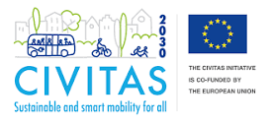
Figure 2 - CIVITAS Funding Disclaimer
The EU logo is a recognized symbol of European Union funding. By using it, a project gains visibility and recognition both within the EU and internationally. This recognition can attract additional partners, collaborators, and stakeholders who may be interested in the project's objectives and outcomes. Many EU-funded projects benefit from being part of a broader network of initiatives and organizations. Displaying the EU funding disclaimer logo can help a project connect with other EU-funded projects, potentially leading to collaboration opportunities, knowledge sharing, and access to a wider pool of expertise.

Since the UK participant of the UNCHAIN project, the University of Lancaster, has received funding from UKRI, their respective logo (Figure 3.) must be included in all communication, dissemination and replication activity and material of UNCHAIN.
Figure 3 - UKRI Grant Logo

Besides these logos, in all official documents the following written disclaimer will be present:
“This document is issued within the frame and for the purpose of the UNCHAIN project. This project has received funding from the European Union’s Horizon Europe research and innovation programme under Grant Agreement No. 101103812. The UK participant in Horizon Europe Project UNCHAIN, is supported by UKRI grant number 10078841 Lancaster University.
Funded by the European Union. Views and opinions expressed are however those of the author(s) only and do not necessarily reflect those of the European Union or CINEA. Neither the European Union nor the granting authority can be held responsible for them.”

Cooperation with similar projects and initiatives
UNCHAIN has already initiated collaboration efforts with various initiatives, associations, and policymakers in the urban mobility sector, with a particular focus on urban logistics. The project is actively tapping into the knowledge available in the global field and leveraging state-of-the-art practices.
UNCHAIN is actively seeking synergies with other Horizon Europe-funded projects, both within the same call and those addressing similar topics. The specific first round list can be found below, filled with projects either falling in the same call as UNCHAIN or the urban logistics topic:
Table 1 - Synergies with other projects
Project Identified | Main Topic | Start Date | Pilot Cities (if any)
DISCO | DISCO aims at fast-tracking up-scaling to a new generation data-driven of urban logistics and smart planning through a Physical Internet led approach. With 48 partners from across Europe, the project is working with 8 Living Labs to demonstrate innovations pertaining to five domains - curb side management (DISCOCURB), proximity based last mile solutions (DISCOPROXI), optimised use of underutilised buildings for last mile logistics operations (DISCOPROXI), shifting to sustainable transport modes (DISCOBAY), and advanced data collection methods (DISCOLLECTION). | May 2023 (42 months) | - Copenhagen (DK)  - Ghent (BE)  - Thessaloniki (GR)  - Helsinki (FI)  - Padua (IT)  - Barcelona + Valencia + Zaragoza (ES)  - Prague (CZ)  - Piacenza (IT)  - Aarhus (DK)  - North Hesse (DE)
URBANE | The growth of the e-commerce sector presents serious logistical issues. In this context, Europe needs to identify and scale up novel and more sustainable last-mile transportation solutions. URBANE (Upscaling Innovative Green Urban Logistics Solutions Through Multi-Actor Collaboration and Physical Internet (PI) - Inspired Last Mile Deliveries) tackles the negative trends associated with last-mile deliveries by supporting the transition towards effective, resilient, safe, and sustainable transport. | September 2022 (42 months) | - Helsinki (FI)  - Bologna (IT)  - Valladolid (ES)  - Thessaloniki (GR)  - Barcelona (ES)  - Karlsruhe (DE)
DECARBOMILE | DECARBOMILE aims to trigger an unprecedented improvement of the green last mile logistics in Europe. To reach that goal, DECARBOMILE relies on a strong experience of decarbonising urban logistics through European initiatives such as CIVITAS. Partners will build upon all previous results to develop improved delivery methods, tools and methodologies, and implement them across Europe. | September 2022 (36 months) | - Logrono (ES)  - Nantes (FR)  - Hamburg (DE)  - Istanbul (TR)  - Tallinn (EE)  - Getafe (ES)  - Ghent (BE)  - Sarajevo (BIH)
ESCALATE | In line with the European 2050 goals ESCALATE aims to demonstrate high-efficiency zHDV powertrains (up to 10% increase) for long-haul applications that will provide a range of 800 km without refueling/recharging and cover at least 500 km average daily operation (6+ months) in real conditions.  ESCALATE will achieve this by following modularity and scalability approach starting from the β-level of hardware and software innovations and aiming to reach the γ-level in the first sprint and eventually the δ-level at the project end through its 2 sprint-V-cycle. | January 2023 (42 months)
SENATOR | SENATOR aims to create a new urban logistic model  for enhancing the sustainability of cities.  For this purpose, the project will develop a smart network operator, as a control tower supported on an ICT Platform that will work as a support tool for decision making, integration and planning of all logistics operations. In consequence, it will minimize the negative impacts that this distribution causes in the cities and will constitute an effective means of collaboration between agents (citizens, operators, transporters and administrations). |  | - Zaragosa (ES)  - Dublin (IRE)
LEAD | LEAD built a ready-to-use digital twin capability, using dynamic data-driven simulation to understand market change needs, work out best response strategies and monitor the impact of new policies and solutions. The digital twin is already online and can be used. | Recently finished project (36 months) | - Budapest (HU)  - Lyon (FR)  - Madrid (ES)  - Oslo (NOR)  - Porto (PT)  - The Hague (NL)
TANGENT | TANGENT is developing new complementary tools for optimising traffic operations in a coordinated and dynamic way from a multimodal perspective and considering automated / non-automated vehicles, passengers, and freight transport. | September 2021 (36 months) | - Lisbon (PT)  - Great Manchester (UK)  - Rennes (FR)  - Athens (GR)
NEMO | The NEMO project - Noise and Emissions Monitoring and Radical Mitigation - will deliver cutting-edge technologies enabling emission-based tolling and mitigation solutions to reduce urban air and noise pollution from transport. Remote sensing, multifunctional barriers and novel road pavements lead the way to cleaner, quieter and healthier urban environments. | May 2020 (42 months) | - Madrid (ES)  - Florence (IT)  - Valencia (ES)  - The Netherlands
DIT4TRAM | This project is developing control concepts and algorithms with swarm intelligence for the widest possible range of application during the project. The four main applications of the Dit4TraM concepts are: Cooperative connected traffic management, cooperative distributed traffic management, decentralised demand management, cooperation between transport services. | September 2021 (36 months) | - Bordeaux (FR)  - Utrecht (NL)  - Amsterdam (NL)  - Glyfada (GR)  - Athens (GR)  - Barcelona (ES)
FlexCurb | FlexCurb is a set of application programme interfaces (APIs) that allow creation of a digital inventory of a city’s curb regulations, so they can visualise and analyse the patterns of curb allocation and use, as well as to adapt and communicate curb regulations. | January 2022 | - Leuven (BE)  - Funchal (PT)  - Strasbourg (FR)  - Toulouse (FR)
UPPER | UPPER aims to strengthen the role of public transport as the cornerstone of sustainable and innovative mobility. The project will implement a combination of measures looking to push people out of private cars and to pull them closer to public transport in cities across Europe. | January 2023 (48 months) | - Valencia (ES)  - Rome (IT)  - Versailles (FR)  - Oslo (NOR)  - Mannheim (DE)  - Lisbon (PT)  - Leuven (BE)  - Budapest (HU)  - Thessaloniki (GR)  - Hannover region (DE)
REALLOCATE | REALLOCATE transforms streets into inclusive, green, safe and future-proof urban spaces, where communities live and thrive. The project enables researchers, mobility experts, urban planners and local citizens to collectively re-imagine our cities and redesign how we move from one place to another. | May 2023 (44 months) | - Barcelona (ES)  - Budapest (HU)  - Gothenburg (SE)  - Hiedelberg (DE)  - Lyon (FR)
SPINE | SPINE aims to accelerate progress towards climate neutrality by integrating public transport systems with new mobility services, sharing schemes, active transport modes, and micromobility. | January 2023 (48 months) | - Antwerp (BE)  - Bologna (IT)  - Tallin (EE)  - Las Palmas (ES)
ELABORATOR | ELABORATOR stands for ‘The European Living Lab on designing sustainable urban mobility towards climate neutral cities’. The project uses a holistic approach for planning, designing, implementing and deploying specific innovations and interventions towards safe, inclusive and sustainable urban mobility. These interventions consist of smart enforcement tools, space redesign and dynamic allocation, shared services, and integration of active and green modes of transportation. | June 2023 (42 months) | - Milan (IT)  - Copenhagen (DK)  - Helsinki (FI)  - Issy-les-Moulineaux (FR)  - Zaragoza (ES)  - Trikala (GR)
GREEN-LOG | GREEN-LOG accelerates systemic changes to create last-mile delivery ecosystems that are economically, ecologically, and socially sustainable. It will establish city platforms made up of inclusive stakeholder Urban Living Labs to foster social innovation, and design/ implement cutting-edge delivery solutions. | January 2023 (42 months) | - Ispra (IT)  - Flanders region (BE)  - Barcelona (ES)  - Athens (GR)  - Oxfordshire (UK)
SUM | The objective of SUM is to transform current mobility networks towards innovative and novel shared mobility systems (NSM) integrated with public transport (PT) in more than 15 European Cities by 2026 reaching 30 by 2030. Intermodality, interconnectivity, sustainability, safety, and resilience are at the core of this innovation. The outcomes of the project offer affordable and reliable solutions considering the needs of all stakeholders such as end users, private companies, public urban authorities. | June 2023 (36 months) | - Athens (GR)  - Jerusalem (ISR)  - Geneva (CH)  - Munich (DE)  - Coimbra (PR)  - Larnaca (CYP)  - Fredrikstad (NO)  - Krakow (PL)  - Rotterdam (NL)
UNCHAIN is a proud member of the dynamic Urban Logistics Cluster established by CIVITAS, and recognizes the importance of specific initiatives like CIVITAS, ALICE-ETP, DigitalTwins4Regions, Living-in.EU initiative, European Network of Living Labs, and DG CONNECT. These partnerships will play a pivotal role in maximizing the impact and exploitation of UNCHAIN's outcomes.
Additionally, the UNCHAIN project is going to create a close collaboration with the DISCO project, as both projects are funded under the same call. While the terms of this close collaboration are not specified as of now, this will include the support of each other’s communication and dissemination activities and the organisation of thematic workshops and the other events. Moreover, the projects can appear together in different conferences and can organise technical capacity building activities. Towards the end of these projects, the DISCO replication and exploitation activities are going to be supported by UNCHAIN, and vice versa.
In addition to a proactive engagement with the initiatives listed in Table 1, the project will aim to get the full potential of the POLIS Working Groups and key European Commission tools to extend our outreach capabilities and ensure that UNCHAIN's innovations reach a broader audience.

Communication Objectives
The communication activities within the UNCHAIN project are strategically designed to achieve the key performance indicators. The project aims to tailor its communication measures to effectively engage a wide range of audiences, extending beyond the project consortium. This inclusivity is crucial to increase the visibility of Horizon Europe and address the societal challenges outlined in the program.
The one primary objective of the project's communication strategy is to effectively inform and demonstrate the positive societal and economic impacts generated by UNCHAIN. From M1 – M12 this objective is going to be accomplished by these activities:
  - UNCHAIN Website
    - Regular updates on the project development.
    - News and events.
    - Dedicated pages for all participating cities and their activities in UNCHAIN.
    - Dedicated pages for all UNCHAIN services.
    - Contact form linked to info@unchainproject.eu address that is forwarded to the project coordinator and dissemination manager.
  - Social Media sites
    - Regular updates on the project development.
    - UNCHAIN project partner introduction.
    - News and events.
    - Social media campaigns directed to the UNCHAIN target groups (see Figure 3.), e.g. UNCHAIN service description campaign.
  - Event attendance
    - UNCHAIN is attending many European conferences (see Table 4.).
    - Physical promotional material (UNCHAIN leaflet, roll-up, poster).
  - Promotional Video
    - Introduction video that will appear on the UNCHAIN website and social media. The video is uploaded on the UNCHAIN YouTube channel and will be embedded from there.
    - If a given event allows the projection of a video, it will appear there as well.
  - Newsletter
    - Two-level newsletter solution (see Section 6.3.4).
    - On LinkedIn the UNCHAIN followers are going to receive a monthly newsletter including updates on the project development.
    - Through the UNCHAIN website, people can subscribe to the “UNCHAIN Members Area” that is a newsletter generated through MailChimp. This bimonthly newsletter is going to include articles provided by the project partners.
  - Magazines and journals
    - UNCHAIN aims to publish articles and op-eds about the demonstration results in prominent industry magazines. These publications will specifically target primary sectors of interest, including local and national newspapers, relevant technical societies, and specialized journals. UNCHAIN will have at least 5 publications. D8.3 – Communication, dissemination and replication v2 (M18) will provide detailed information about this activity.
  - Peer-reviewed Scientific Publications
    - In order to increase the UNCHAIN dissemination, UNCHAIN is going to have at least 2 peer-reviewed publications submitted until M21, January 2025. D8.3 – Communication, dissemination and replication v2 will provide detailed information about this activity.
The key elements that drive the UNCHAIN communication on all online and offline platforms are detailed in Section 6.2.
To achieve the primary objective, the project will communicate tangible results and success stories arising from its validation activities. This approach not only highlights the project's significance but also ensures that its achievements are comprehensible and relatable to a broad audience. The target groups are presented in Table 2, in which the target groups and related entities are identified.
To create a consistent and recognizable project identity, UNCHAIN has developed a brand and visual identity, including promotional materials and common templates for presentations. This branding effort contributes to identity, consistency, and visibility across all project-related materials and activities. Additionally, the project established a dedicated website (www.unchainproject.eu), maintains a strong presence on social media (LinkedIn and Twitter), and distribute e-newsletters. The details of the UNCHAIN online presence with their These channels serve as comprehensive information hubs, offering insights into the project's evolution, objectives, partners, demonstrations, results, publications, news, events, and best practices. These elements have been presented in detail in D8.1 that has been submitted in M4.
A strategic media planning approach will be deployed to ensure that all project milestones are presented and reach the targeted audience. Continuous monitoring and adaptation of communication actions will be carried out to ensure their effectiveness and to make any necessary corrections. This is supported by Google Analytics on the UNCHAIN website, and the social media monitoring tools.
Overall, these communication objectives are strategically designed to maximize the visibility, impact, and success of the UNCHAIN project while ensuring clear communication and effective engagement with a diverse range of stakeholders.
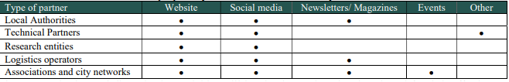
In the table below, the specific communication and dissemination related target groups (“Type of partner” in Figure 4.) are shown as included in the Grant Agreement:
Figure 4 - UNCHAIN Communication and Dissemination Partner Types

Target Groups of UNCHAIN
WP8 will follow this table presented in Figure 4 as the main guideline during the preparation of any communication and dissemination material. However, the consortium further developed this table into more specific sections presented in Table 2.
The following channels have been identified for communication and dissemination:
- Website
- LinkedIn Social Media Channel
- Twitter Social Media Channel
- Printed material (e.g. leaflet)
- Video
- Newsletter
- Magazines
- Scientific Journals
- Events
    - Conferences
    - Workshops (organised by UNCHAIN)
- Stakeholder Engagement Group (SEG)
Table 2 - Target Groups per Communication Channel
Target Group | Description of Group Members | Related Communication Channels
Primary Direct Target Group | - Local and Regional Authorities  - Transport Planning Agencies  - Urban Logistics Operators  - Policy Makers  - Freight Transport Operators | - Website  - LinkedIn  - Printed Material  - Video  - Newsletter  - Magazines  - All events  - SEG
Secondary Direct Target Group | - Transport consultants  - Mobility Service Providers  - Technology Providers  - Managers of Logistics Hubs and UCC/UDC | - Website  - LinkedIn  - Twitter  - Video  - Printed Material  - Newsletter  - All events  - SEG
Knowledge Direct Target Group | - Research Institution  - Researchers  - Academia  - Data Working Groups | - Website  - Printed Material  - Events  - Scientific Journals  - Magazines  - SEG
Indirect Target Group | - Civil Society Organisations  - Local Businesses and E-commerce providers  - General Public and City Residents  - Retail Businesses  - Receivers and shippers of goods  - Costumers of delivery service industry products | - Website  - Twitter  - Video  - Newsletter  - Magazines  - Workshops

Project motto
The UNCHAIN project motto was unanimously decided upon during the early stages of project development. The project consortium collectively agreed on the motto without the need for a vote by external individuals. This collaborative decision-making process ensured that the chosen motto resonated with a broad audience. The outcome of this effort is now the official motto of the UNCHAIN project:
“Embrace the brand new era of urban logistics”
This motto now serves as a unifying message across all project communications, from promotional materials to the project website, ensuring a cohesive and impactful presence. The motto projects a forward-looking and innovative mindset. It suggests that UNCHAIN is not just addressing current urban logistics challenges but is actively shaping a new era. This perspective can capture the attention of stakeholders who are looking for cutting-edge solutions.
It emphasizes urban logistics, which is a critical concern in the face of growing urbanization. It immediately shows the project's focus, making it relevant and relatable to urban planners, policymakers, and residents. The use of "embrace" carries a positive connotation, suggesting a collaborative and inclusive approach. Moreover, this phrase is easy to remember, is concise and aims to carry a sense of inspiration.
As discussed in D8.1, most of the UNCHAIN promotional material will be translated into the local languages of the participating cities. One of the translations (Italian) was successfully conducted to be presented at the UNCHAIN project consortium meeting in Florence, Italy. The participating partners (POLIS, City of Florence) dealt with the translation process and a linguistic difficulty had to be overcome. Namely that the primary motto does not translate well to Italian.
While all partners believe that the primary motto, "Embrace the brand new era of urban logistics," effectively communicates the project's vision, recognizing the importance of linguistic nuances, the secondary motto, "UNCHAIN all potentials with our urban logistics services," was introduced to ensure that the project's objectives are clear and resonant in all languages. This linguistic inclusivity allows us to connect with a broader range of stakeholders, making the project more accessible and relatable on a global scale. While the primary motto sets the overarching tone and direction of the project, the secondary motto puts an emphasise related to the 12 UNCHAIN urban logistics services.

Key messages of the UNCHAIN project
The main objective of the project communication is emphasising the significance of the sustainable logistics innovation in the urban space. Withing the sustainability, urban logistics and cooperation domains, there are multiple specific messages identified to use in the UNCHAIN communication and dissemination activities. For example, if one of the UNCHAIN project partners is attending a specific event on zero-emission cities and must give a presentation on UNCHAIN, they can use these taglines below to alter the message based on the specific topic. These are not the primary project motto, “Embrace the brand new era of urban logistics”, however, they aim to complete it. While the project motto has been established with the aim to create an engaging message about UNCHAIN, the taglines want to give an insight into the actual work in the project.
The creation of these aims to help to work of all project partners in dissemination and communication activities. Since they have access to a resource on how to effectively communicate and what are those messages that can effectively paint a picture of our project, they do not have to worry about coming up with attention grabbing taglines on their own.
It is important not only to communicate about the project objectives, but also about deeper commitments that the project partners share and wish to showcase throughout the project outcomes. These messages have been organised into three categories:
- Sustainability:
    - Reducing carbon emissions and footprint
“UNCHAIN: Leading the Way to Carbon-Neutral Urban Logistics”
    - Better air quality in the urban areas
“Clean air, clean vision: UNCHAIN’s Commitment to Urban Well-being”
    - Enhancing the urban quality of life
“Transforming Cities, Transforming Lives: UNCHAIN for a Better Urban Experience”
    - Creating cities for the future
“UNCHAIN: Building Smart and Sustainable Cities for Generations to Come”
    - Resilience for the cities
“Building Urban Resilience: UNCHAIN's Journey Towards Sustainable, Future-Ready Cities”
- Urban Logistics:
    - Cutting-edge urban solutions
"UNCHAIN: Tomorrow's Urban Logistics Solutions Today"
    - Economic benefits
"Elevating Cities, Elevating Economies: UNCHAIN's Impact on Urban Prosperity"
    - The 12 services at the forefront of innovation
"UNCHAIN's 12 Innovative Services: Shaping the Future of Urban Logistics"
    - State-of-the-art urban solutions
"From Tradition to Transformation: UNCHAIN's State-of-the-Art Urban Logistics Solutions"
- Stakeholder Cooperation:
    - Public-private cooperation
“Bridging the Gap for Sustainable Urban Logistics through Public-Private Collaboration”
    - Scalability and replication
“Scaling Success: UNCHAIN's Model for Replicable Urban Logistics Solutions”
    - Multi-stakeholder collaboration
“Unlocking Potential Together: UNCHAIN's Multi-Stakeholder Approach to Urban Logistics”
    - Leadership in sustainable innovation
“Leading the Way in Sustainable Innovation: UNCHAIN's Vision for Future-Ready Urban Logistics”

Target Groups
The following table outlines the diverse target groups that the UNCHAIN project is actively engaging with, each with their related key messages. Effectively communicating with these target groups is essential for the successful dissemination of our project's goals and outcomes. By tailoring our messages to suit the specific needs and interests of each group, we can maximize the impact of our efforts and ensure the relevance of UNCHAIN to a wide range of stakeholders.
Table 3 - List of Communication and Dissemination Target Group
Target Group | Description of Group Members | Related Key Message
Primary Direct Target Group | - Local and Regional Authorities  - Transport Planning Agencies  - Urban Logistics Operators  - Policy Makers  - Freight Transport Operators | All messages
Secondary Direct Target Group | - Transport consultants  - Mobility Service Providers  - Technology Providers  - Managers of Logistics Hubs and UCC/UDC | Urban Logistics
Knowledge Direct Target Group | - Research Institution  - Researchers  - Academia  - Data Working Groups | Sustainability; Urban Logistics
Indirect Target Group | - Civil Society Organisations  - Local Businesses and E-commerce providers  - General Public and City Residents  - Retail Businesses  - Receivers and shippers of goods  - Costumers of delivery service industry products | Sustainability

Online Presence

Accessibility
Accessibility and inclusivity are core values to all UNCHAIN project partners as well as for the project as a whole. During the creation of all communication and promotional material, these values were always prioritised over design. UNCHAIN worked with graphic designers and web developers who also share this as an important principle. The concept of inclusivity and accessibility the partners adopted in UNCHAIN is inspired by the vision projected by Susan Goltsman.
“Inclusive design doesn’t mean you’re designing one thing for all people. You’re designing a diversity of ways to participate so that everyone has a sense of belonging.” – Susan Goltsman

An accessible online presence ensures that everyone, regardless of their physical abilities or disabilities, can access and interact with the UNCHAIN content and services. It promotes inclusivity, upholding the principle that everyone should have equal access to information and resources.
Accessibility features, such as alt text for images, proper heading structure, and keyboard navigation, often enhance the overall user experience for all users. These features make content easier to navigate and understand, which can lead to increased user satisfaction.
UNCHAIN uses all available accessibility features on the website as well as on the social media platforms. Prioritising this results in a current 98/100 accessibility score on the UNCHAIN website. This number has been provided to the UNCHAIN consortium by the web developer and designer company Josworld that supported WP8 lead POLIS in the promotional material development.
On the UNCHAIN social media, the admins always use alt texts and do not use too many emojis either. The usage of these elements, might create a visually pleasing outcome, however will cause difficulties for people living with visual impairments, since dictation systems cannot read these out.
Within WP8, there is going to be an accessible communication workshop organised by POLIS for all project partners to share best practices on how to implement this in their personal and organisational communication in the online sphere. This will be an online workshop that coincides with the kick-off of the local communication strategies (see Section 6.4).

Website
The project website is operated under the domain name www.unchainproject.eu. The website has been specifically created to capture the attention of all target groups identified by the project.
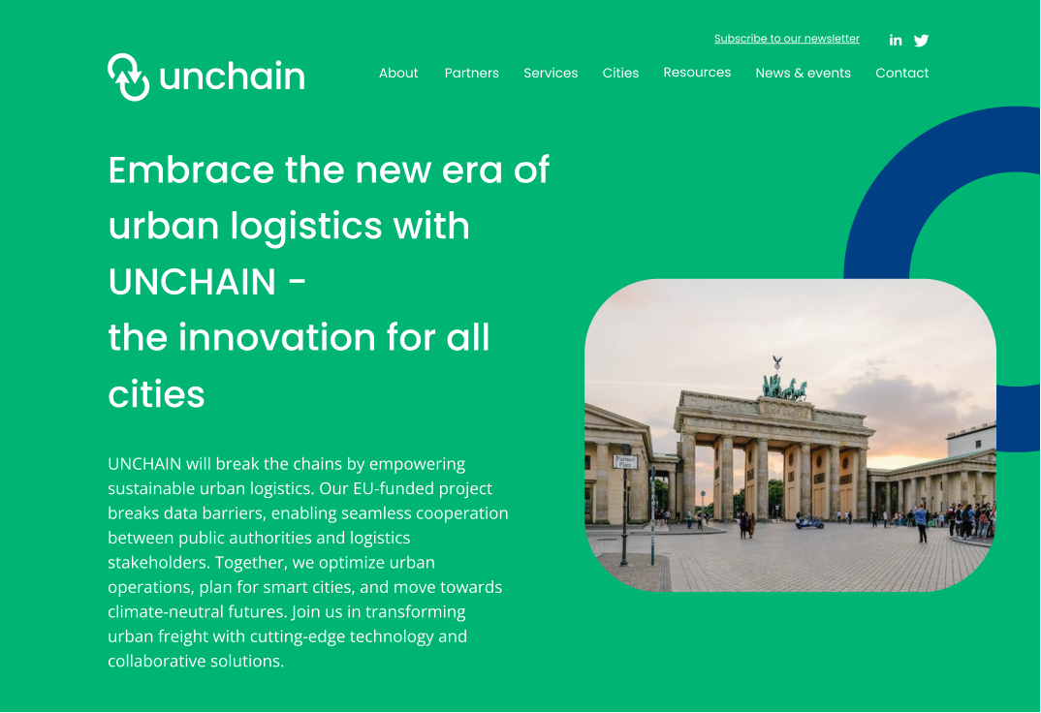
Figure 5 - UNCHAIN Website Landing Page
The website includes a detailed “About” page, that explains the project in a way that a wider audience can also understand it. The “Partners” tab includes 18 pages – one for each partner with a short description and their logos. Under the “Services” tab all visitors can find all necessary information about all UNCHAIN services. These pages are going to be regularly updated as the project continues its development. The “Cities” tab currently includes dedicated pages for the three UNCHAIN Living Labs, that are also going to be updated as the project progresses.

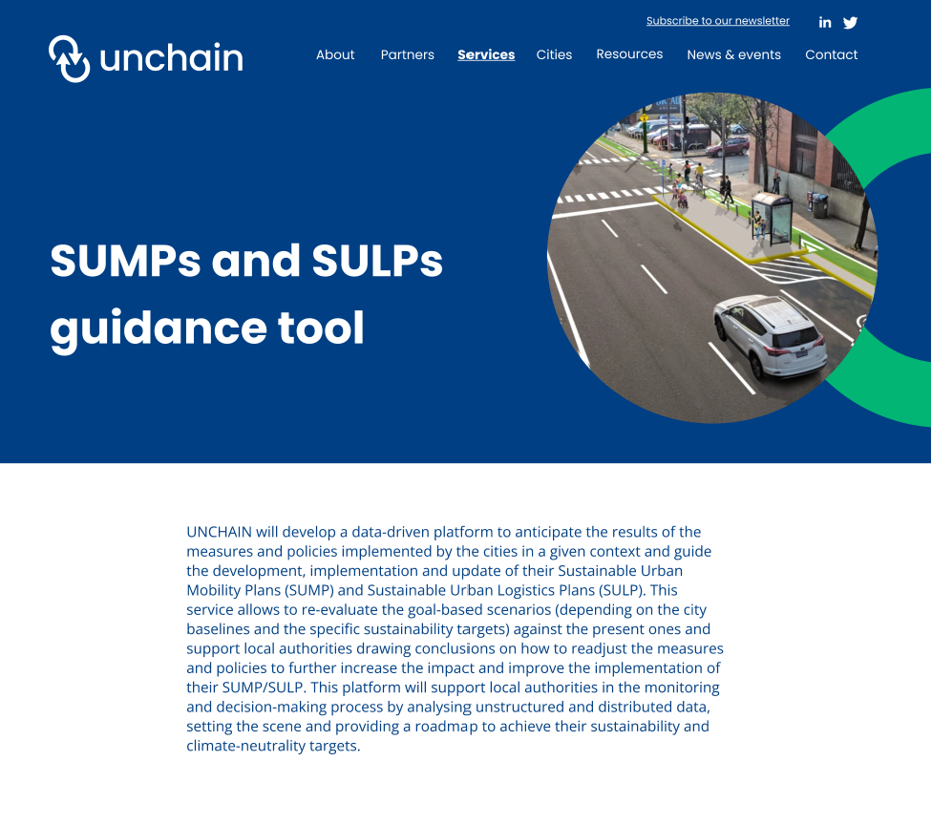
Figure 6 - Service page for SUMPs and SULPs guidance tool
Besides all the dedicated pages, the website includes a “News and Events” tab and a contact page where the website visitors can content the project with any questions through the info@unchainproject.eu email address. Four project consortium members have been appointed to receive emails to their personal email addresses through the common UNCHAIN email address. This will ensure that someone will be available at all times to monitor any inquiries and make sure that the messages reach the current partner.

Monitoring Indicators (Website)
The website has Google Analytics to keep track of all visitors and the general traffic on the website. The web developer who currently has the hosting rights of the website will provide the WP8 leader POLIS with all necessary metrics every month. Google Analytics enables users to track up to 200 different metrics to measure how their websites are performing.
The metrics UNCHAIN will monitor from the website are:
  - Users
    - A user is a unique or new visitor to the website.
    - Number of users per month to monitor KPIs.
  - Bounce Rate
    - The percentage of visitors who viewed only a single page.
    - This metric is highly important, as it tells whether the website is designed in an appealing way.
  - Average Session Duration
    - How long on average each visitor stays on the site.
    - Like the “Bounce Rate” this is an important metric to monitor the effectiveness of design on the website.
  - Percentage of New Sessions
    - The percentage of website visits that are first-time visits.
    - Monitoring this metric will allow UNCHAIN to see when it is time to create updates. Moreover will show how effective the social media campaigns are. New visitors usually arrive from social media and following a conference attendance.
  - Pages Per Session
    - The average number of page views per each session.
    - This metric indicates how engaged our website visitors are. A higher number of pages per session typically suggests that visitors are exploring the UNCHAIN website, finding content of interest, and are more engaged with the project. By tracking this metric, it can identified which pages or content are most popular among the visitors.
POLIS will keep track of all data and share it with the WP8 partners whenever necessary. The website is completely GDPR compliant (see Section 3.1.).
This data will be key to shape the UNCHAIN online presence, as it provides better insights on user demographics, user behaviour, website traffic. A more detailed analysis of the project’s online reach will be presented in D8.3 in M18.

Social Media Channels
As described in D8.1, the UNCHAIN project established two social media channels. The project is currently present on LinkedIn and Twitter. The social media activities, like the website, aims to communicate towards all target groups.
During the social media activities that have been conducted so far in the project’s lifetime, the WP8 partners have identified some trends. It is clear that the UNCHAIN followers engage more with content that includes pictures of members of the project consortium. The partners are also more likely to reshare/repost these sorts of content, resulting in a much higher reach. Therefore, there is an emphasis on sharing visual content on the UNCHAIN social media channels.
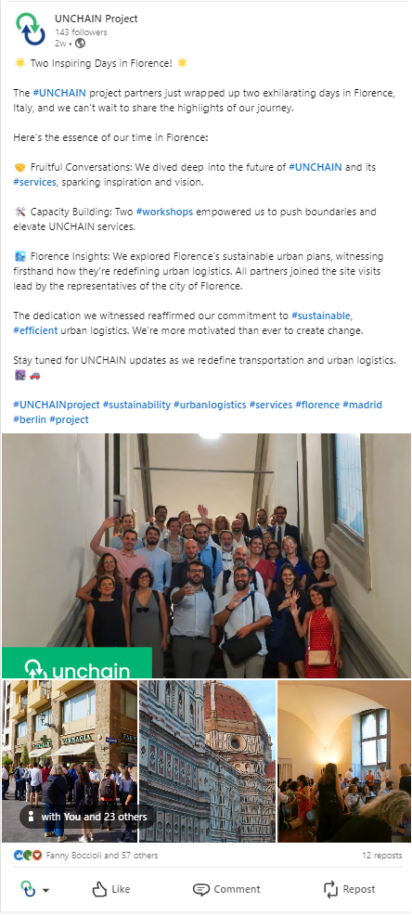
Figure 7 - Example of an engaging post on the UNCHAIN social media
Posting this type of content resulted in already reaching not only the midterm KPI for social media following, but also the end of project KPI. As a result, the UNCHAIN consortium has recognised the potential for even greater ambition and has decided to set more ambitious KPIs for our social media following. The new targets have been adjusted to 250 on LinkedIn for the midterm and 350 by the end of the project in 2026. While, these refined KPIs will be thoroughly reviewed and discussed in detail in D8.3, a preliminary social media KPI table has been prepared for the first year of the project (see Table 4. Below).
Table 4 - UNCHAIN New KPIs
Activity | GA KPI (mid-term) | New KPI (mid-term)
Website Visitors | 150/month | 200/month
Twitter Following | 75 | 80
LinkedIn Following | 75 | 250

Monitoring Indicators (Social Media)
Both of the current social media sites have built in monitoring tools. This helps to monitor the engagement and see the success of each post.
The LinkedIn platform even allows the admins to see how the UNCHAIN project page does compared to its competitors. The competitors as seen below on Figure 7 and 8, are not business competitors of UNCHAIN and the projects will actively collaborate with the other project. UNCHAIN has identified these other pages based on the fact that these are project pages that wish to reach a similar audience and are also EU funded projects in the realm of mobility/logistics.
As of September, and October 2023, the UNCHAIN project is leading the follower and organic content engagement metrics compared to its online competitors. This is thanks to the project’s attendance at the Urban Mobility Days 2023, and a highly active project consortium that is proudly sharing the project content on their personal pages.

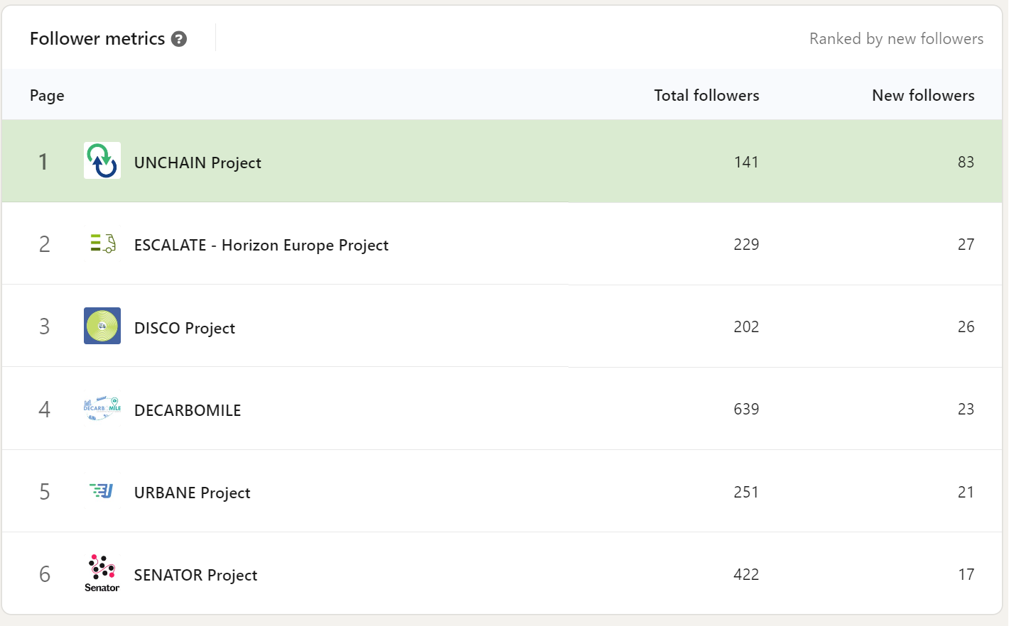
Figure 8 - UNCHAIN LinkedIn Follower Metrics compared to competitors
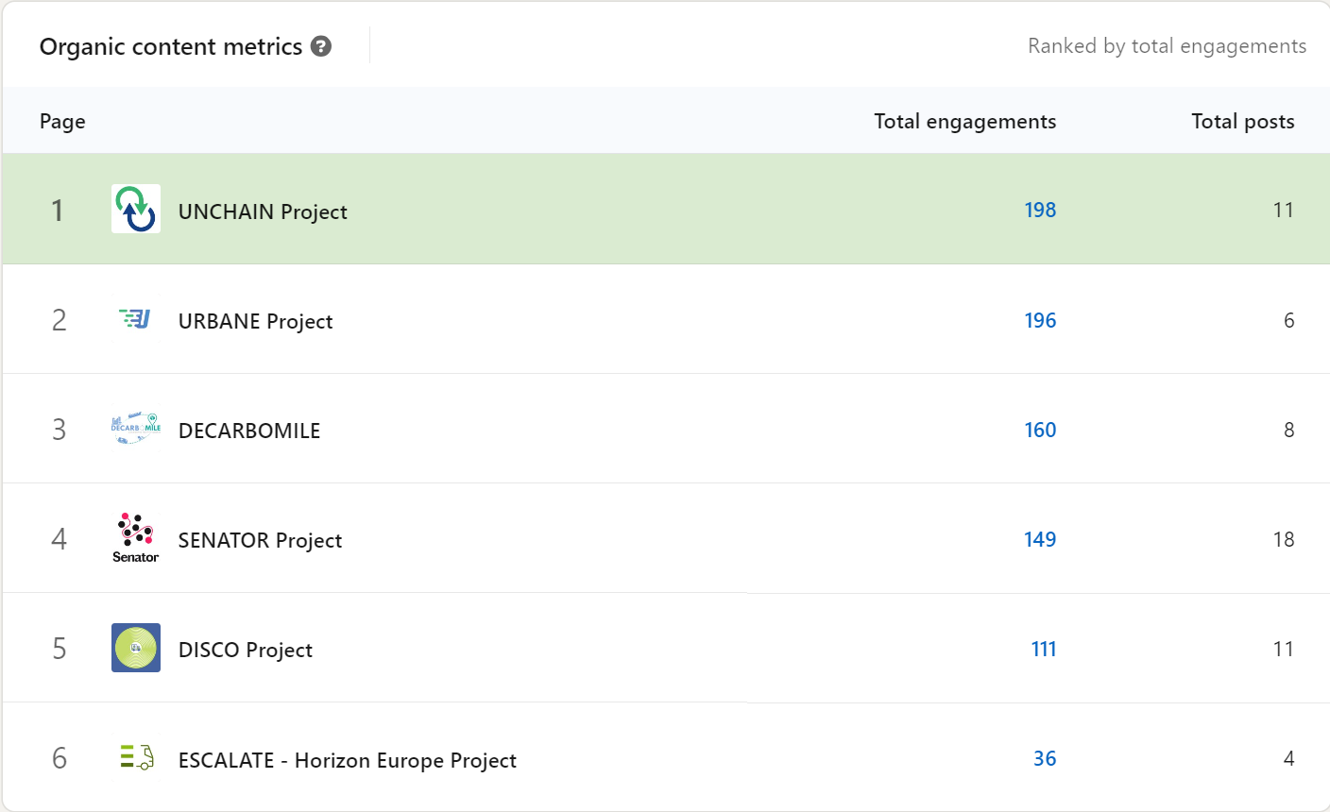
Figure 9 - UNCHAIN LinkedIn Organic Content Metrics compared to competitors
In D8.3 in M18, a more detailed overview is going to be provided with insights on the success of the communication activity and strategy. The WP8 leader POLIS has developed a social media calendar for the first year with the purpose to keep track of all project milestones and make sure that UNCHAIN always has content ready to share and engage with. The first one (Project Partner Introduction Series) is already running successfully on all social media platforms.

Newsletter
The UNHAIN project is using the “mailchimp.com” website to create and distribute the newsletters, that allow us to invite up to 500 subscribers. When necessary, this number can be extended.
The UNCHAIN project’s newsletter follows the general “Data Processing Addendum” of Mailchimp. This data processing procedure is compliant with both GDPR and the International Data Transfer Addendum issued by the Information Commisioner's Office under S.119(A) of the UK Data Protection Act 2018. Any data collected through the Mailchimp newsletter subscription is going to be stored in the UNCHAIN Alfresco repository. The UNCHAIN consortium will not give this information to any third party. This collected information (name and email address) is only going to be used for sending out the newsletter and for no other activity.
The newsletter will be circulated bimonthly to all subscribers and will provide all relevant news about UNCHAIN. This includes important project milestones, interesting events and all necessary information. The creation of the text within the newsletter will be supported by all project partners and POLIS serve as an editor.
On the top and bottom of the page of the website every visitor is going to be encouraged to subscribe to the UNCHAIN newsletter. If this method turns out to be not successful in getting newsletter subscribers, this will be adjusted to a more efficient CTA message. The CTA message is GDPR compliant.
The subscribers of the Mailchimp newsletter of UNCHAIN are going to be addressed as “UNCHAIN members” as this will create a deeper sense of belonging. A secondary newsletter is going to be launched on the UNCHAIN LinkedIn page as a LinkedIn feature to maximize the reach. LinkedIn sends out an automatic notification to all UNCHAIN page followers with a CTA message, then the followers can decide whether they wish to subscribe.
This LinkedIn newsletter is going to be sent out every month with the project development and project partner news. This newsletter follows the LinkedIn GDPR and general data protection rules, that is described here. UNCHAIN does not store any data related to the LinkedIn newsletter.

Local communication strategy
As the UNCHAIN project has 10 cities participating, the WP8 partners agreed on establishing local focused communication strategies. The expected outcome of these specific strategies is to have higher level engagement with the project even amongst those who do not use English as a working language. This will positively contribute to the dissemination, upscaling and creating a high-level legacy for the UNCHAIN project.
While the official local work has not kicked off yet, many elements in the overall strategy already supports it. These elements include the multilingual nature of the website, the translated leaflet, poster and later the brochure.
The specific reasoning behind the creation of the local strategies:
  - Tailoring messages to local audiences
While cities share many challenges, different regions also have to deal with specific ones based on their location. Adjusting the message to something that works better locally will establish a deeper understanding and a sense of connection to the project. The given local UNCHAIN partners will take the lead on this adjustment in collaboration with the WP8 lead. By having local plans, UNCHAIN can customize the messages to resonate with the specific interests and priorities of each city and region.
  - Building local ownership
Local plans will specifically incentivise the participating cities to take ownership of the project’s goals as well as feel more connected with the project as a whole instead of just focusing on their given case studies. When cities feel the project is relevant to their needs and aspirations, they are more likely to actively participate and contribute to its success.
  - Overcoming language and cultural differences
Europe is linguistically and culturally diverse. Local communication plans can address language barriers and cultural nuances, making it easier for residents and stakeholders in each city to engage with the project. This enhances the accessibility and effectiveness of the UNCHAIN communication efforts.
  - Maintaining local networks
Local communication plans allow us to tap into existing local networks, organizations, and mobility influencers. Partnering with local stakeholders and authorities can amplify our project's reach and impact within each city, as these entities often have established credibility and trust within their communities.
  - Creating local stakeholder engagement
Local communication plans enable us to engage with local stakeholders, such as businesses, NGOs, residents, and academia, on a more personal and relevant level. This can lead to more meaningful partnerships and contributions to the project. During the creation of the UNCHAIN Stakeholder Engagement Group (section 8.1.1), the local networks will be engaged as well to maximize the effectiveness.
  - Showing the local success stories
The progress created by the project Living Labs in the UNCHAIN project can serve as a success story for that region. Local communication plans allow us to highlight these success stories, inspiring other cities and demonstrating the tangible benefits of participating in the project. In the plan there is going to be a high focus on how the local population can benefit from the UNCHAIN project. While reaching the specific outcomes of a project is important, communicating this to a wider audience is also essential. As the UNCHAIN project is funded by the EU, the whole consortium finds it vital to showcase how we are contributing to the sustainable development and green transition of Europe.
  - Connect this with the local dissemination plans
One of the most important objectives of creating the local communication plans is to enhance the effectiveness of the dissemination strategy. Building up a wide stakeholder and local network until the UNCHAIN project has its first result is vital. The project will organise workshops, seminars, and community events within each city to directly engage with residents and stakeholders. These opportunities will be used to showcase project outcomes, demonstrate their impact, and gather feedback.

Establishing the Local Strategies
The local communication plans are currently under development between ETRA, POLIS Network, the 3 Living Labs and 4 other participating cities. While the local strategies are only going to be presented in depth in D8.3 in M18, the specific steps to take in the development have been set already.
The steps the UNCHAIN project is going to take to develop the local strategies:
- Identifying Local Communication Managers
The first step is to identify local communication managers that are in regular contact with T8.1 leader, POLIS. While this responsibility may appear to go above the scope of T8.1, the appointed managers will not be burdened with additional work. The underlying objective is to organise the information flow and improve the internal understanding within the project.
These Local Communication Managers will be the recipients of monthly briefings from POLIS, offering insights into the effectiveness of WP8 activities. In return, they will play an essential role in providing POLIS with important information about local events, policy shifts, and developments. This valuable input will be used to enrich the UNCHAIN website, newsletters, and various social media platforms.
- Sending out a Communication and Dissemination survey to each Local Communication Managers
The survey will be specifically designed to investigate the needs of the 7 participating cities will be circulated in M7-M8 of the UNCHAIN project. The results of this will be processed within the scope of T8.1 – Communication activities.
The survey includes the following overall themes that are enriched with many follow-up questions, that all cities have to provide an answer to:
- What do you wish to accomplish with the UNCHAIN activities related to WP8?
- What are the messages you would like to convey regarding WP8 activities?
- What are the local target audiences you want to reach?
- Do you plan to organise UNCHAIN local event?
- Do you plan to create local communication material for UNCHAIN?
- Process the outcome of the survey
After receiving the filled-out surveys from each participating city, the answers are going to be processed. Once identified of overarching themes and specific local needs, POLIS is going to create a dedicated document to support each local communication manager in planning.
- Create specific recommendations for each city
In the dedicated document the cities will find captivating taglines, eye-catching visuals, clever communication strategies, and insightful recommendations on how to steer local activities in the right direction. These suggestions are not just about addressing various needs; they are aimed at elevating communication efforts to meet the high standards set by the UNCHAIN overarching project communication, dissemination, and replication plan.
- Measure success
Measuring whether these plans are successful is vital to succeed in the project strategy. This is how the UNCHAIN partners will learn best practices and can see how theory works in practice.
The local communication and dissemination plans will be based on workshops, seminars, webinar that will target different groups. After each event like this, the participants are going to be asked to fill out a survey about their opinions on the event. After processing this, the UNCHAIN partners can make adjustments and if needed rethink the planning.
- Adapt our overall strategy
The communication, dissemination and replication strategy is going to be updated twice during the UNCHAIN project lifetime. These are perfect occasions to rethink how we tackle this WP and related tasks. However, the local communication managers will play a key role in this. It is highly important that the WP8 leader POLIS, has regular check-ins with these Managers to measure the effectiveness as well as intervene whenever necessary.

Dissemination Objectives
UNCHAIN will facilitate the dissemination of communication activities among all project partners. Partners will utilize their external and internal channels, such as websites, newsletters, reports, and social networks, to promote the project, increase its impact, engage new audiences, and find networking opportunities. The UNCHAIN project is already showcased on many project partner organisation’s website and in many newsletters, such as the biweekly InfoPolis (Polis Network newsletter).
The project will also collaborate with external stakeholders, including related projects, institutions, and media outlets, to ensure a high level of outreach for communication activities. This external collaboration will help maximize the project's visibility and impact. This specific objective will be supported by the establishment of the Stakeholder Engagement Group and the creation of the local communication strategies.
To facilitate engagement and knowledge dissemination, UNCHAIN will organize a variety of events, including awareness events (including webinars and open days in the Living Labs targeting the general public), workshops, and a final event. These events are designed to bring together local and European stakeholders from the business, local authority, and academic sectors to experience the project's demonstrations and learn about its findings.
Additionally, the project will create publications in various forms tailored to different types of audiences. These publications will present the key outcomes of UNCHAIN, addressing both the business community, academia, and citizens.
Lastly, UNCHAIN will produce guidelines and lessons learned that are clear, precise, and attractive. These documents will highlight all the details of the project's development and implementation, explaining how others can use the project's innovations after its completion. These materials will be included within the project's regulatory guidelines, harmonization, and policy recommendations.

Multistakeholder Approach
The UNCHAIN interdisciplinary approach is also translated into the dissemination activities. As established in the GA it is vital for the project to have a consortium that involves a truly innovative cluster that covers the whole value chain. WP8 meant to translate this into all communication and dissemination activities and aims to prioritize it when presenting UNCHAIN.
This multi-disciplinary and multi-stakeholder approach is the cornerstone of the project's user-centred development. It aims to ensure that various viewpoints and interests are considered throughout the development and deployment processes while preventing foreseeable externalities. In this context, UNCHAIN project takes an interdisciplinary approach, integrating complementary disciplines.
This diverse expertise ensures that all facets of the project, from technological advancements to economic viability and societal impact, are comprehensively addressed during dissemination activities.
Furthermore, UNCHAIN reinforces its multi-disciplinary approach by engaging the UNCHAIN Stakeholders Engagement Group, which will include representatives of European and local actors. These stakeholders play a pivotal role in dissemination, communication, and replication activities, further enriching the project's outreach with their diverse backgrounds and expertise.
Therefore, UNCHAIN's interdisciplinary approach in dissemination activities is not only crucial but also highly effective. It enables the project to engage with a wide spectrum of stakeholders, cater to diverse interests, and communicate its findings and benefits comprehensively. This approach aligns perfectly with the project's user-centred development goals and is key to ensuring successful implementation and replication of its results.

Strategic Dissemination
The primary objective of the dissemination strategy is to ensure that UNCHAIN effectively communicates, disseminates, and exploits its project objectives and outputs to both consortium members and external stakeholders. By doing so, the project aims to achieve positive and long-lasting results by sharing research findings with key stakeholders, potential users, industry peers, policymakers, and the general public. The dissemination strategy distinguishes between two main aspects: dissemination directed at key stakeholders and users, and communication directed at the general public and media.
The primary focus in all communication and dissemination activities is on the 12 UNCHAIN urban logistics services. This was identified as an effective method, since if the activities emphasize the participation of the 7 cities, the focus might shift to the city specific case studies and what is achieved there, instead of seeing the project together as an innovative initiative.
The target groups of the dissemination activities correlate to the same target group discussed above in in Table 2 and 3.
Exploitation and dissemination are highly important even after the project lifetime. This can ensure a long-lasting project impact and legacy, that the whole UNCHAIN partner consortium aims for. Dissemination and communication will in particular target potential beneficiaries, including logistics operators and their drivers, technology providers, national and local government departments and agencies, UCC/UCD managers. Other stakeholders include the research and academic community, citizens and environmental organisations. The consortium will make use of all tools provided by the EC to support the project’s dissemination and exploitation activities:
  - Open Research Europe platform
  - Horizon Results platform
  - Innovation radar
  - TRIMIS platform

Event Attendance
Attending on different conferences, workshops, seminars/webinars is crucially important for the UNCHAIN project dissemination objectives. In relation to event attendance, more specific local events are going to be identified by the Living Lab cities in order to integrate them into the local strategies.
Below is the table that serves as the first collection of different events where the UNCHAIN consortium could effectively showcase the project main ideas and outcomes later in the project lifetime. In the table the sign “*” shows events where the UNCHAIN project has already been showcased or the UNCHAIN participation has already been confirmed.

Table 5 - UNCHAIN Event Attendance
Event Title
Urban Mobility Days *
Global Mobility Call *
Annual Conference of Major Cities of Europe *
Smart City Expo World Congress *
TRA (Transport Research Arena)
TRB
ITS World/Europe
ITF
WCTRS
POLIS Conference
CIVITAS Forum
EUROCITIES Conference
EARPA Forum
European Conference on Sustainable Urban Mobility Plans
Smart Mobility Congress
International Conference on Ecological Vehicles and Renewable Energies
TECMA Feria Internacional de Urbanismo y Medio Ambiente (Spain)
Greencities (Spain)
Transfiere (Spain)
Odysseus (International Workshop on Transport and Logistics)
INFORMS
Tomorrow Mobility World Congress
Mobility World Congress
Sustainable Energy Week (EUSEW)
European Week of Regions and Cities
ECOM World
Hybrid and Electric Vehicle Conference (HEVC)
Vehicle Power and Propulsion Conference (VPPC)
Triennial Symposium on Transportation Analysis (TRISTAN)

Replication Objectives

Scalability and Replication
The UNCHAIN project places a strong emphasis on ensuring that its research results have a lasting impact on society, science, and the economy/technology sectors. To achieve this, UNCHAIN has devised a comprehensive dissemination and scalability strategy that involves engaging with a wide range of stakeholders and the transferability of the results via the implementation of different activities.
One key aspect of this strategy is the establishment of a Stakeholder Engagement Group (SEG) that is expanded on in Section 8.1.1. This group is designed to create a trusted community comprising peer-cities, regions (referred to as "early adopters"), and other stakeholders who can play a pivotal role in the project's success. The SEG's primary function is to facilitate the dissemination, validation, and uptake of UNCHAIN's innovative solutions.
The adoption roadmap will encompass a range of critical elements, including transferability guidelines, exploitation strategies, and business plans. It will serve as a practical guide for cities and regions looking to successfully adopt and implement UNCHAIN's innovative solutions.
In addition to its collaboration with the SEG, UNCHAIN's efforts align with the POLIS Network Working Groups and the permanent POLIS-ALICE public-private stakeholder dialogue, both focused on accelerating the transition to CO2-free city logistics by 2030. UNCHAIN will communicate its results to the European Union (EU) in the form of policy briefs, contributing to broader policy initiatives.
UNCHAIN's strategy for replication and scalability is designed to engage peer-cities and stakeholders actively, promote sustainable logistics solutions, foster knowledge exchange, and provide valuable input for policy development. These efforts are geared toward maximizing the project's societal, scientific, and economic impact.

Stakeholder Engagement Group
UNCHAIN will invite public authorities from various cities and regions to join the SEG. These peer-cities and regions will closely follow UNCHAIN's project developments, validate its results, and actively engage in discussions with project partners. The aim is to generate significant interest for UNCHAIN's tools and services while fostering knowledge sharing and exchange among cities and regions.
The SEG's role extends beyond mere participation, as it actively supports the implementation of innovative and sustainable logistics solutions across Europe. This collaborative effort is expected to enhance the operational capacity of city authorities and businesses, particularly logistics operators and small and medium-sized enterprises (SMEs).
Several peer-cities have already expressed their interest in joining the SEG, including Ravenna Municipality (Italy), Brest Métropole (France), and Alba Iulia Municipality (Romania). These cities will play an active role in the SEG's activities and contribute to its success.
Furthermore, the SEG will serve as a valuable source of input for specific project tasks, including Task 7.4, Task 8.2, and Task 8.3. This input will be instrumental in the development of a comprehensive policy package of recommendations and an adoption roadmap.
The SEG in its full multi-level way will start its operation in January 2024. After reaching out to all interested stakeholders, the SEG and UNCHAIN project partners will set up a calendar for workshops and milestones for the SEG to operate as effectively as possible. The very first SEG meeting is going to be organised in person to set up the working programme of the group. The last SEG meeting is also going to be a real-life meeting, currently planned to take place before the UNCHAIN final event in Brussels.
The stakeholders will meet at least twice a year online to support the UNCHAIN activities and provide the consortium with impactful comments.

Multi-level Stakeholder Engagement Group
Members of the SEG will have the flexibility to choose their level of involvement in various peer-learning activities. Options range from receiving project updates through mailing lists, social media, and the project website to more active participation, such as reviewing project outputs, attending UNCHAIN events (including workshops and interviews), and contributing to feasibility studies of selected services.
This approach is meant to address a modern world issue, that industry professionals and stakeholders are often members of many different groups, are subscribed to many newsletters. Therefore, some people tend to neglect their group memberships as they have too many of them.
In Section 6.3.4 related to the UNCHAIN newsletter, this issue has been brought up. With the newsletter subscription, people will become members of UNCHAIN. This will give them a bigger sense of belonging as they will receive exclusive content, such as interviews with UNCHAIN partners and deeper industry insights. The overarching aim of this membership is to create a long-lasting legacy with an established UNCHAIN network. The membership system serves as the secondary level of the Stakeholder Engagement Group. Invitation to become a member will be sent through the UNCHAIN social media channels and will be communicated on the website as well.

Transferability activities
UNCHAIN transferability activities are designed to support the promotion and adoption of the project results and innovations, as well as knowledge sharing and best practice exchange between pilot, followers, and peer cities. Transferability activities include the development of city baseline cards, replication trainings, peer-to-peer exchange webinars, workshops, and on-site peer learning visits. The main output of these activities are the transferability guidelines that will guide the adoption of UNCHAIN results by external interested stakeholders and that will be included as part of UNCHAIN Knowledge Powerhouse for urban logistics. These guidelines serve as a roadmap for applying the project's findings and are an integral part of the UNCHAIN Knowledge Powerhouse for urban logistics—a centralized resource hub storing all knowledge and materials related to the UNCHAIN project, accessible to those seeking to enhance urban logistics in their own contexts.
The Knowledge Powerhouse is going to be included on the UNCHAIN website later on in the project lifetime. EIT Urban Mobility, ETRA and POLIS have found a creative solution to integrate the Knowledge Powerhouse in an interactive and user-friendly way. Including this on the main website will increase the visibility of this service.

Contribution to Standardisation
The standardization objectives within the UNCHAIN project are critical to ensuring the successful exploitation of its solutions in the market. Standards play a pivotal role in shaping a functional marketplace, and for UNCHAIN, they are instrumental in achieving several key goals.
Firstly, considering existing standards in the development of UNCHAIN's solutions is essential to ensure that the project's results align with established industry practices. This alignment enhances interoperability and compatibility, making it easier for UNCHAIN's innovations to find broad market application. By adhering to industry standards, UNCHAIN aims to create solutions that seamlessly integrate with existing systems and technologies.
Furthermore, UNCHAIN recognizes the importance of promoting its research results and influencing the development of future standards. By actively participating in standardization activities, the project can contribute to shaping industry norms that are conducive to the uptake of its innovations. This proactive approach to standards development can significantly facilitate the market acceptance of UNCHAIN's solutions.
Standardization activities are considered a valuable tool within UNCHAIN's strategy for scalability and replicability. These activities not only support the future transferability of project outcomes but also promote their widespread use. By aligning with industry standards, UNCHAIN positions itself to tap into a larger market while ensuring its solutions meet the necessary quality and compatibility requirements.
Drawing from the extensive experience of its project partners in smart cities projects, energy, and quality management standards, as well as their collaboration with organizations like CEN/CENELEC, UNCHAIN recognizes the need for a shared and common approach to innovative processes. While innovation often thrives on flexibility, having a standardized framework simplifies the understanding and adoption of these innovations from various perspectives, including technical, administrative, and financial.
Technical standards have a unique characteristic that makes them valuable in risk reduction. They are based on universal criteria of transferability, essentiality, transparency, and sharing. These principles align closely with accounting and sustainability protocols adopted by the credit and finance system. Standards can be seen as tools to ensure materiality and consistency, making them valuable assets in navigating the complexities of sustainable urban development.
For instance, at the city level, various standards can be implemented to drive the transition towards sustainability and smartness. These standards can facilitate the introduction of innovation in technical, administrative, and financial approaches. Examples include standards related to energy and environmental management systems (such as ISO 50001 and 14001), sustainable cities and communities (ISO 37100 series), energy audits (EN 16247-series), energy efficiency benchmarking (EN 16231), and many others.
Within UNCHAIN, specific actions will be taken to address standardization. Task 7.4.2, known as Standardization Activities, will involve investigating the standardization potential of the project's outcomes. UNCHAIN will actively engage with related standardization technical committees to assess the extent of collaboration required to capture their inputs as stakeholders. This collaborative approach ensures that UNCHAIN's solutions align with industry standards and can seamlessly integrate into existing frameworks.
Notably, UNCHAIN will benefit from the expertise and leadership of Mr. Bernand Gindroz, who holds key positions in standardization bodies, including chairman of CEN/CENELEC/ETSI Sector Forum Smart and Sustainable Cities and Communities, chairman of ISO TC 268 (Sustainable Development of Smart Strategic planning and policy making), and head of ISO delegation in the ISO/IEC/ITU Joint Task Force on smart cities UNSDGS, among others. His involvement underscores UNCHAIN's commitment to actively shaping and adhering to industry standards in pursuit of its objectives.

Key Performance Indicators to achieve
While KPIs are invaluable tools for measuring the success of our established UNCHAIN communication, dissemination and replication strategy, it is essential to remember that they are a means to an end, not the end itself. Relying solely on KPIs can inadvertently narrow our focus and limit our creativity. The UNCHAIN consortium unanimously agrees that this project has the potential to create lasting impact, therefore, a legacy.
A holistic strategy recognizes that true success goes beyond mere metrics. It is about creating meaningful connections, fostering engagement, and delivering valuable content to our audience. By complementing our KPIs with a broader perspective, WP8 aims to ensure that the project does not lose sight of the human element – the individuals, communities, and stakeholders it aims to reach.
When KPIs are used as guides rather than rigid directives, we open ourselves to innovation, adaptability, and the capacity to respond authentically to our audience's evolving needs. It's not just about achieving numbers; it is about making a genuine impact. Remembering that KPIs are tools in our communication toolbox, but our strategy should always be driven by the project mission, values, and the desire to connect on a deeper level with those we aim to serve.
With this mindset, UNCHAIN already achieved some of its established midterm KPIs. However, the consortium is not one that will be satisfied with achieving mere numbers. The objective is to create impact and always stay ambitious.
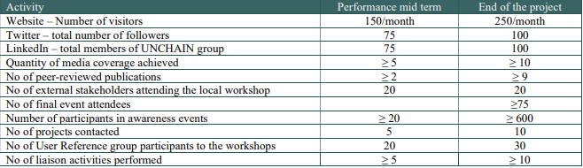
Figure 10 - KPIs for WP8

Conclusion
In conclusion, the UNCHAIN project is committed to creating a unified identity, engaging with a wide range of stakeholders, and ensuring the scalability and replication of its innovative solutions in the field of urban logistics. Through a comprehensive communication strategy, including the use of logos and written disclaimers, active collaboration with similar projects and initiatives, and the establishment of a SEG, UNCHAIN aims to maximize its impact and visibility. The project places a strong emphasis on accessibility and inclusivity in its online presence and actively participates in various events and conferences to showcase its objectives and outcomes.
The project is dedicated to promoting sustainability, urban logistics, and stakeholder cooperation through its communication efforts. UNCHAIN recognizes the importance of engaging with a diverse range of target groups, including logistics operators, government departments, academic communities, and citizens. By following the open access approach, UNCHAIN will share all research findings and innovations with key stakeholders and the general public.
To ensure the long-lasting impact and legacy of the project, UNCHAIN gives special importance to replication and scalability. The establishment of a SEG, with multi-level engagement options, and the development of transferability activities, including guidelines, are integral to this goal. Standardization efforts are also a key component of the project, aiming to shape a functional marketplace for its innovative solutions.
In summary, the UNCHAIN project is not only committed to advancing urban logistics but also to ensuring that its efforts have a broad and lasting impact on society, science, ultimately contributing to more sustainable and efficient urban logistics systems.

Annex I.

POLIS Network Privacy Policy
The whole document is available on the dedicated page of the POLIS Network website.

POLIS Network Cookie Policy
The whole document is available on the dedicated page of the POLIS Network website.
UNCHAIN does ensure that the site meets the user’s expectations. If they have any comments or concerns about cookies on the UNCHAIN website, all users can contact Zsofia Jakoi (zjakoi@polisnetwork.eu), Melina Zarouka (mzarouka@polisnetwork.eu) and Alexia Collignon (acollignon@polisnetwork.eu) of POLIS Network to address these.

